Thank you for registering for the Canadian Parents for French Alberta Falling into French Weekend. We have planned a fun-filled family weekend of French and bilingual activities for French and non-French speakers, based out of Coast Canmore Hotel (511 Bow valley Trail) Canmore, Alberta. This will be an opportunity for students to use and practice French outside of their school setting from Friday, October 20 - Sunday, October 22, 2023.

Please take a moment to read through everything below as some action is required on your part for your children to be able participate in all the activities.

There is a swimming pool at the hotel so you may want to bring your swimsuits. Pool, Hot Tub and Fitness Centre – Guests may need to register and book a time at the front desk (upon arrival) to use the pool, hot tub and fitness centre.
Please note that any food allergies/needs are accommodated for at all hotel meals and during Saturday's youth programming. Most meals are buffet style and platters will be labeled, should a further accommodation be needed please let hotel staff know.
Schedule:
*Times & activities may vary
MUST complete climbing wall waiver for children & youth – please see link and instructions below.

Friday, October 20
Hotel check in any time after 4 pm. You will be required to leave a credit card number upon check-in for any incidentals. Room charges and taxes have been covered by CPF through your registration fee.

- 6:00pm – 10:00pm: Welcome in the lobby. Look for our CPF banner and welcome booth table in the main concourse past hotel check in desk.
- Pick up your CPF Logo wear from our table.
- Opportunity to purchase some exclusive CPF drinkware.
- If you arrive in Canmore later in the evening and we are no longer in the lobby we will register you with us Saturday morning.
- For those that have youth in grades 7 -12 attending our Falling into French Family weekend, our monitor & monitor-in-training manual will be shared by email. Youth are expected to read it before Saturday. All youth in this age group will be given information at the event outlining expectations and role. A brief check list will be performed at 8:15am Saturday am.

Saturday, October 21

7:15 -8:30 am: Breakfast at the hotel, this is included in package. Our "welcome booth" will also be set up for those who arrived later than 10:00 pm on Friday.

8:15: monitors and monitors-in-training (All youth grades 7-12) will complete a brief checklist in the lobby (by the main ballroom on concourse)

8:30: Children must be in lobby (by the main ballroom on concourse) to commence age-appropriate sociocultural activities.
  - Please wear provided name tags.
  - *MUST complete the Canmore Climbing Gym waiver please:
- Waiver Requirements
- All participants must have a waiver signed.
- All children must have waivers signed by a legal guardian and saved to their account before arriving. This is very important as we will not be able to let anyone climb without the waiver (unless the parent or legal guardian is present with them of course and can sign on the spot).
- The link to create an account for parents/legal guardians where they will add a dependent to their account can be accessed at CCG's Portal.

- Waiver Instructions
Step1| Parent/Legal Guardians will create an account for themselves using the link provided, and their own information first.

- Step 2| Use the household tab on the left panel to add a household member using their dependant's information.

- Step 3| Use the sign waiver tab on the left panel to sign for themselves and their dependant at the same time.
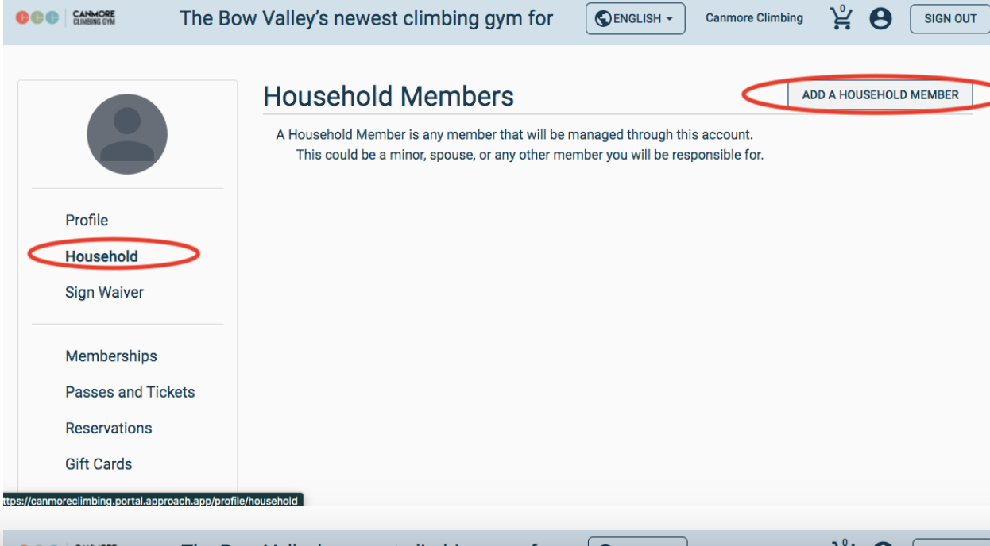

  - Participants should bring for climbing:
    - Clean soled indoor shoes – not sandals - to climb in
    - Long comfortable pants or shorts that extend past mid-thigh to accommodate the harnesses. Dresses and skirts are not comfortable with climbing harnesses or for yoga in the afternoon.
    - We recommend youth bring a backpack to hold their items including snacks provided by CPF Alberta.
  - Please send them with a full water bottle.
  - Youth must be prepared to be outdoors for a portion of Saturday’s events (they will be going between the indoors and outdoors) and mountain weather can be cold at this time of year so please ensure that they bring appropriate outerwear; this includes a toque, ski-pants, boots, mittens/gloves etc.
  - Afternoon activities - Heads up – Painting clothes suggested for the afternoon activities. A large t-shirt, apron etc. to throw on top their clothes to protect them from splatters.

8:45 – 12:00: – Babysitting service is available for those under 5 (Free of charge).
- Must complete Medical waiver

9:00 - 10:00: CPF Alberta AGM – AGM documents will be available on our website. https://ab.cpf.ca/en/agm/

10:00 - 11:00: – Parent Session – Join us for a fun and engaging session - On Mastery of the language has long been viewed as THE French immersion goal. But is there more than mastery of the language for our French immersion students? Can French immersion be more than that? New and exciting trends in French immersion education show that developing positive attitudes, habits, and understanding about being a language learner can help students see themselves as being bilingual from a younger age. As a parent who might not speak the language, it can be tricky to know how to support your child in finding joy, being curious and developing the confidence to take risks in a new language. This session will explore how parents can support their French immersion child’s journey outside of the mastery of the language and through the development of positive attitudes and habits for life presented by Dr. Sarah Fédoration.
Dr. Sarah Fédoration is the Manager of English as an Additional Language and Language programs, including French immersion at Edmonton Catholic Schools. The French immersion program left such a mark on Sarah that she pursed a career as a teacher, consultant, and advocate of the program. She is proud to be able to work in a program that is close to her heart and is passionate about sharing her knowledge about the program with teachers, leaders, and parents.

11:00 - 12:00: - Chapter Training Session – How to Fundraise

12:00 - 1:30 – Free time for lunch. Lunch is not included by CPF. Children & Youth participating in activities will be provided a packed lunch. *Excludes those in babysitting service

1:15 – 3:15 – Babysitting service is available for those under 5 (Free of charge).

1:30 – 3:00 - Parent Activity – (Paint-nite) activity with Nathalie but done in the afternoon – all skills welcome!
Please confirm your participation at CPF registration table. $20 per participant
3:15 – pick up children from babysitting
3:30: Children & Youth activity is complete, signed back in by parents

3:30 – 5:30: Free time

5:30 - 6:30: Dinner at the hotel - included in package. Extra drinks including adult beverages can be purchased at the onsite bar. Please ask the wait staff for assistance.

6:30-8:00: – Crock-a-doodle activity for the Monitors, Monitors-in-training and babysitters. Treats will also be provided.

7:00 – 8:00: Family Entertainment – L’ Association La Girandole Performance – Traditional French jig plus special performance by the youth

Sunday, October 22

8:00 - 09:30 Breakfast at the hotel- included in package.
Check out of hotel.

11:00 Family Activity – Cave & Basin National Historic Site - Guided Tour (maximum 28 participants)
11:30 Second tour – if numbers warrant
When not on the tour participants are welcome to visit the boardwalks, the site film, exhibits and internment exhibit.
- CPF staff will ask you to confirm your attendance at the welcome table.

Saturday Bilingual Youth Programming:

Child/youth Schedule – please complete climbing wall waiver

8:30: Children must be in lobby (by the main ballroom on concourse) to commence age-appropriate sociocultural activities.
9:00 – 11:30: Groups will be split in two and alternate activities throughout the day
- Dance workshop by La Girandole – at Canmore Rec Centre
- Climbing at Canmore Climbing Centre

11:30-12:30: Lunch break - Lunch will be provided to the children/youth at Rec centre

12:30 – 2:45: Group A & B will alternate between
- Yoga/Craft
- Youth will enjoy a historical and interactive workshop with the Canmore Museum

Please send your child with:
  - Name tag
  - Dress appropriately for the weather – Programming INCLUDES outdoor activities.
  - Dress in comfortable stretchy clothes for climbing wall and yoga
  - Clean indoor Running shoes for the climbing wall
  - Backpack for snacks & their personal items. i.e., Water bottle etc.

3:30: Children & Youth activity is complete, signed back in by parents in the lobby

If you have any questions, please feel free to email us at cpfab@ab.cpf.ca.

Any issues while you are on site please contact:

Michael Tryon 780-860-1248
or
Trish Rognvaldson 403-844-5736

Donations accepted for CPF Alberta – Our endowment found details can be found HERE.

